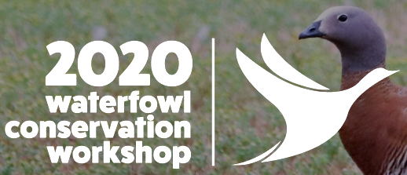
Travel Stipend Application Form
A travel stipend is intended to cover a percentage of the cost of air fare or other expenses required for the applicant to attend the Waterfowl Conservation Workshop. Applications are evaluated by need, involvement in waterfowl conservation or husbandry and history of previous financial assistance.

Applicant’s Name: Click here to enter text. Applicant’s Title (if applicable): Click here to enter text.
Organization (if applicable): Click here to enter text. Website: Click here to enter text.
Mailing Address: Click here to enter text.
Email Address: Click here to enter text. Phone: Click here to enter text.
Are you 18 years of age or older? ☐ Yes ☐ No Are you an IWWA member? ☐ Yes ☐ No
Describe why you would like to attend the Waterfowl Conservation Workshop: Click here to enter text.

Describe your work history and/or experience with waterfowl: Click here to enter text.

How will you apply the information you receive at the Waterfowl Conservation Workshop? Click here to enter text.

Will you be traveling internationally for the Workshop? ☐ Yes ☐ No
If so, do you have a current passport? ☐ Yes ☐ No
Amount of funding requested: Click here to enter text.
How will funding be spent? Click here to enter text.
Have you applied for Workshop funding previously? ☐ Yes ☐ No
Have other sources of funding been sought or received? If so, please indicate from whom and in what amount:
Click here to enter text.

Acceptance of Workshop funding is conditional based on the following provisions:
- Recipients of funding must present on a mutually agreeable topic at the Workshop
- Acknowledgement of the International Wild Waterfowl Association and Sylvan Heights Bird Park must be included in any printed or electronic presentations relating to your experience at the Workshop
- Any remaining funds not spent on attending the Workshop must be returned within one month after the Workshop

☐ Yes, I understand the provisions above and agree to abide should my application be approved

Applicant’s Name: Click here to enter text. Date: Click here to enter text.

Funding applications must be submitted for review by the Waterfowl Conservation Workshop committee. Applications and any supporting documents should be submitted to:
Mr. Brent Lubbock (Brent@shwpark.com) and Mr. Ian Gereg (ian.gereg@gmail.com)
Successful applicants will be contacted directly. Funds are distributed after acknowledgment of the award has been received from the applicant.

